Spreadsheet

**Class Six**

**Lab 22**

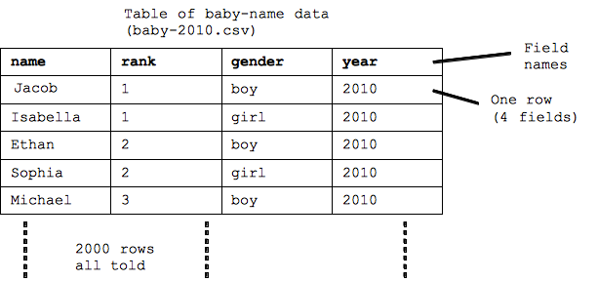

## Create a sheet like above using Google Sheet